
COMSATS
University Islamabad, Lahore Campus

Department of Computer Sciences

Lab Assignment – Semester Spring 2025
Course Title | Software Testing |  |  |  |  | Course Code |  | CSE455 | Credit Hours: | 3
Course Instructor | Ms. Yella Mehroze |  |  |  |  | Program Name |  | BSE
Semester | 8th | Batch: | FA21-BSE |  | Section | A,B |  | Assigned | May 3rd 2025
Total Marks | 30 | Obtained Marks: |  |  |  | Due Date | June 1st,2025
Student’s Name | Aoun-Haier |  |  |  |  | Reg. No | FA21-BSE-133

Question 1: [Marks 15]
Jmeter is an open-source java based performance testing tool which provides different options to create thread (users), listeners, samplers, recorders inside a test plan
Launching Jmeter using command prompt:
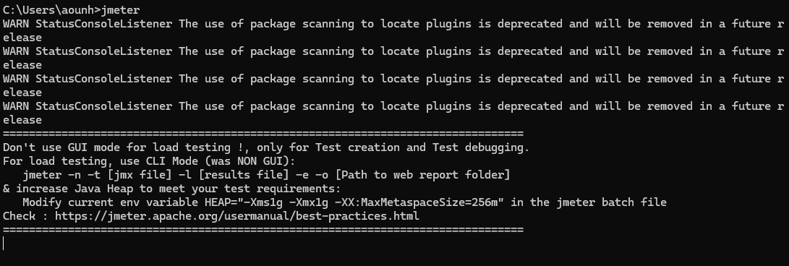

Creating a test plan:
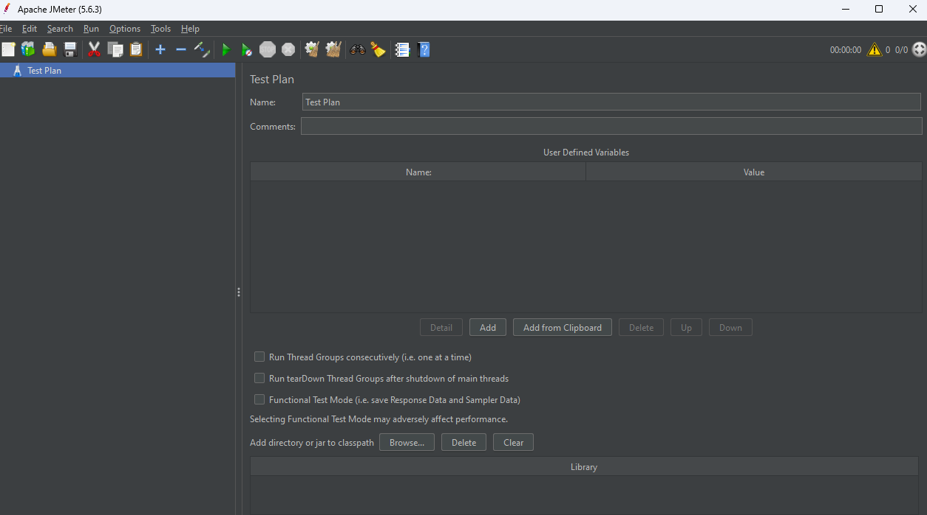
Creating thread group inside the test plan:
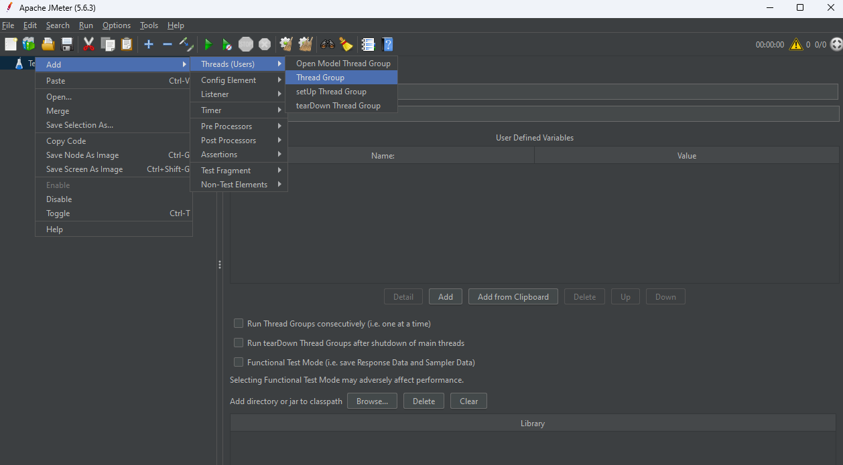
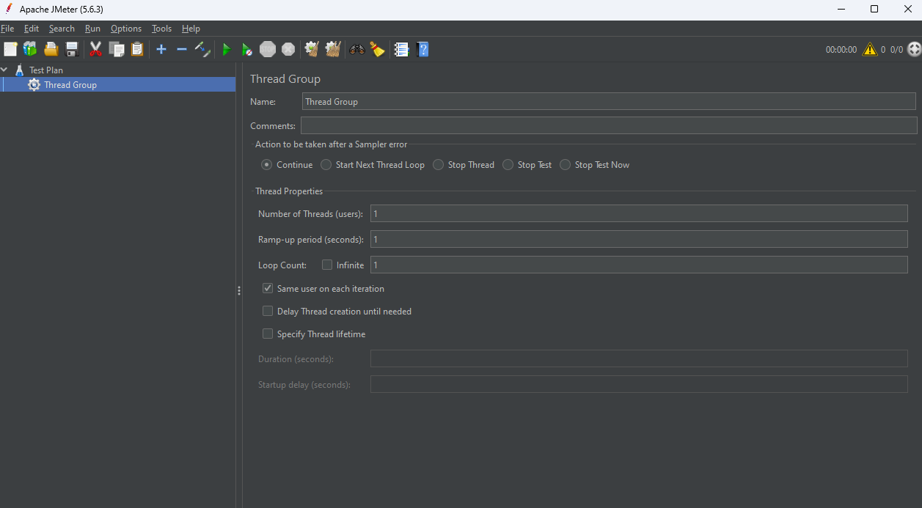

Test plan contains different elements like Sampler for sending requests, Listeners are used to view the result of sampler in the form of table, graphs, trees or simple text in some log files, Timer is used to set time between requests to simulate real request.
Let's perform the test on sample API reqres.in

After creating test plan and adding thread group, add a sampler 'HTTP Request':
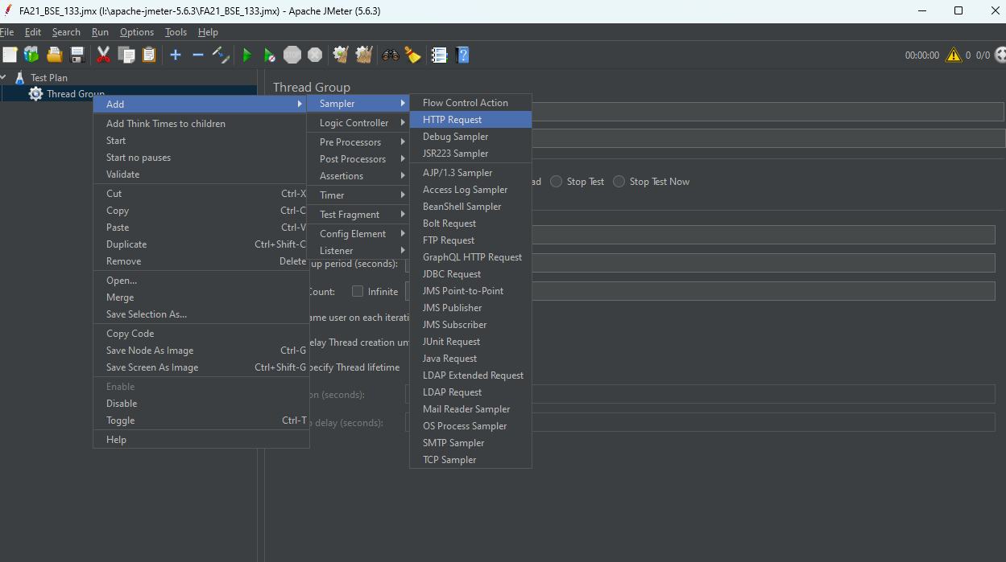
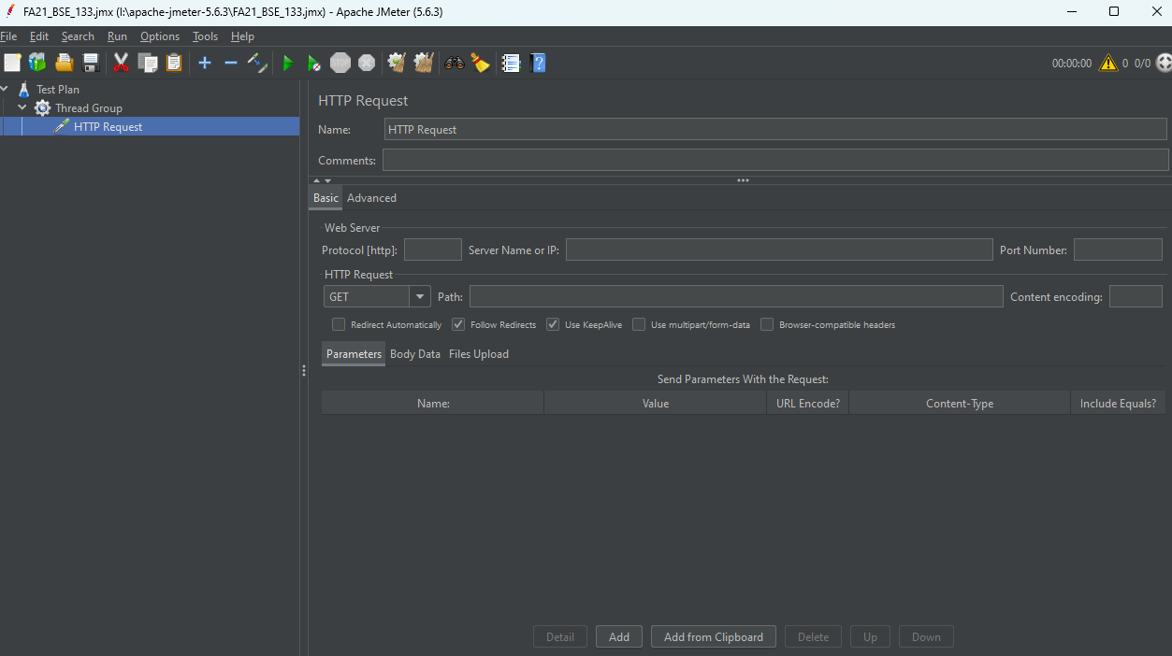

Provide protocol, ip, path and parameters in the empty fields:
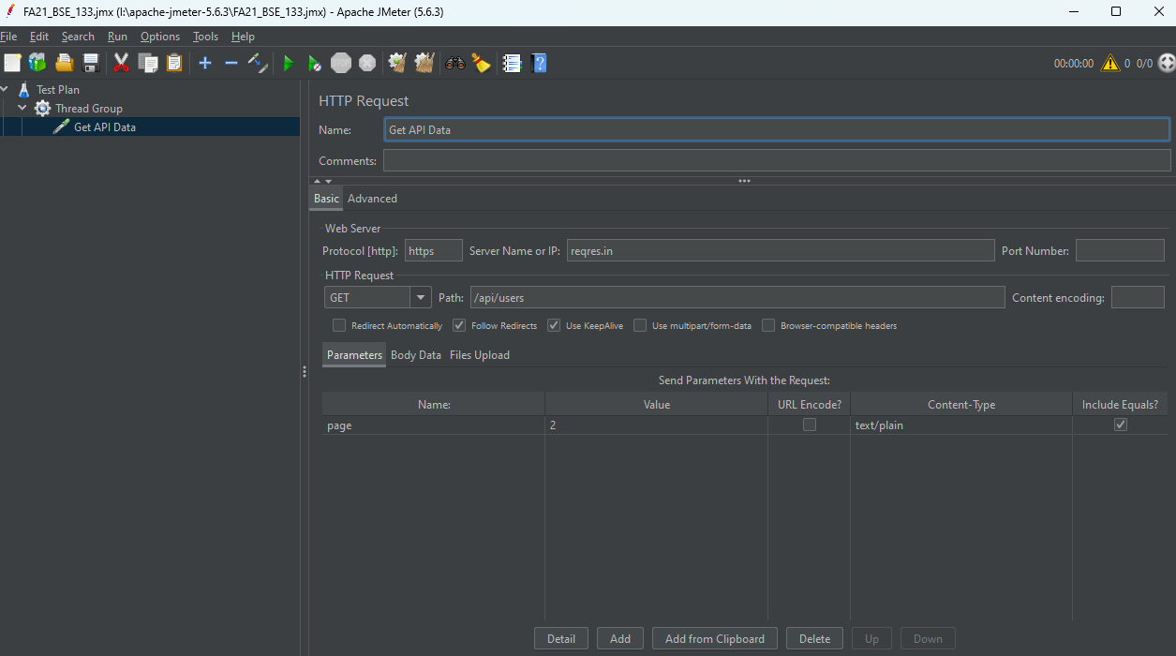
Now add a listener 'View Results in Table' for viewing the result in some way:
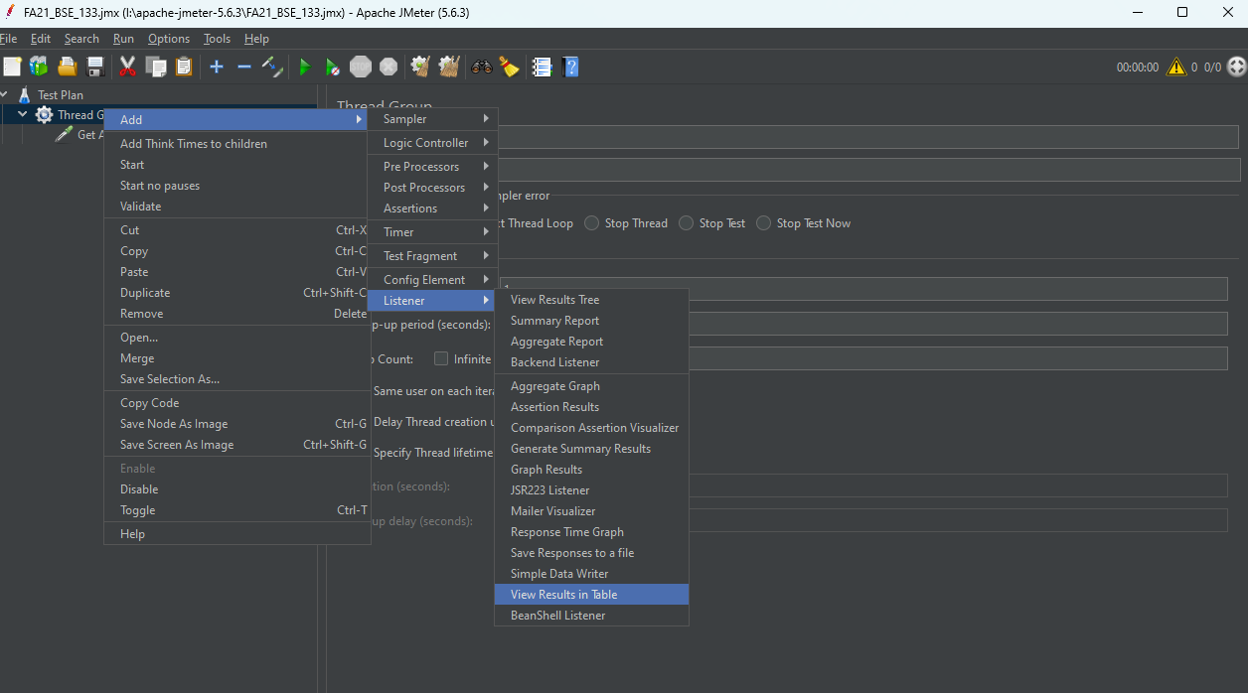
Also add 'View Results Tree' listener in thread group:
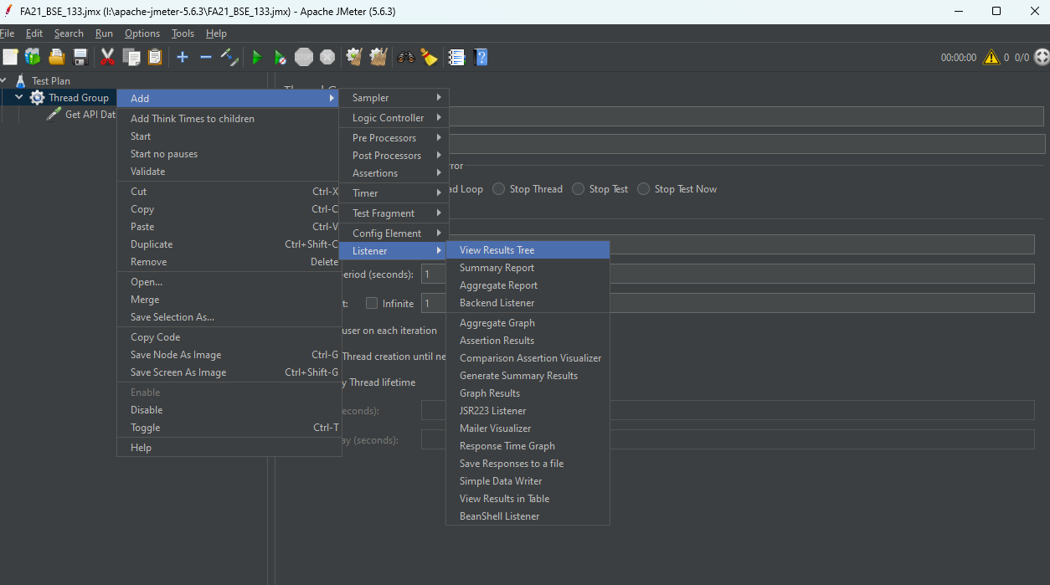
Change the number of users in thread group to 10 and run the test by clicking the green button
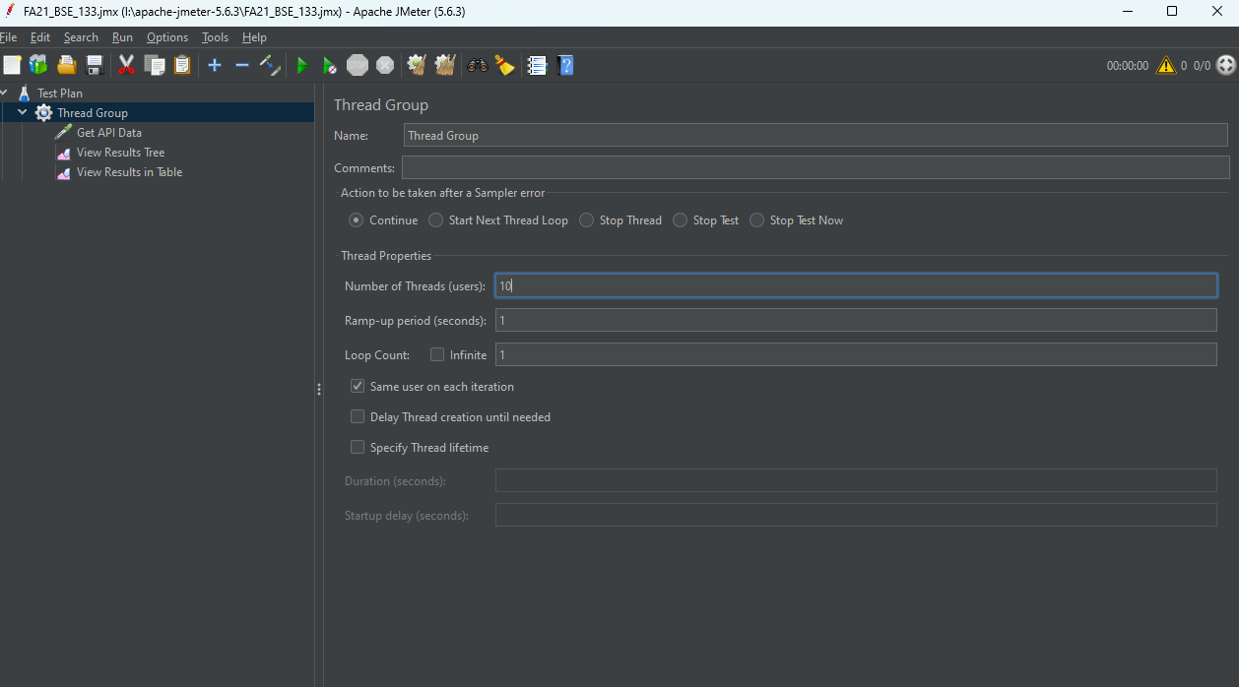

We can view the result in both listeners:
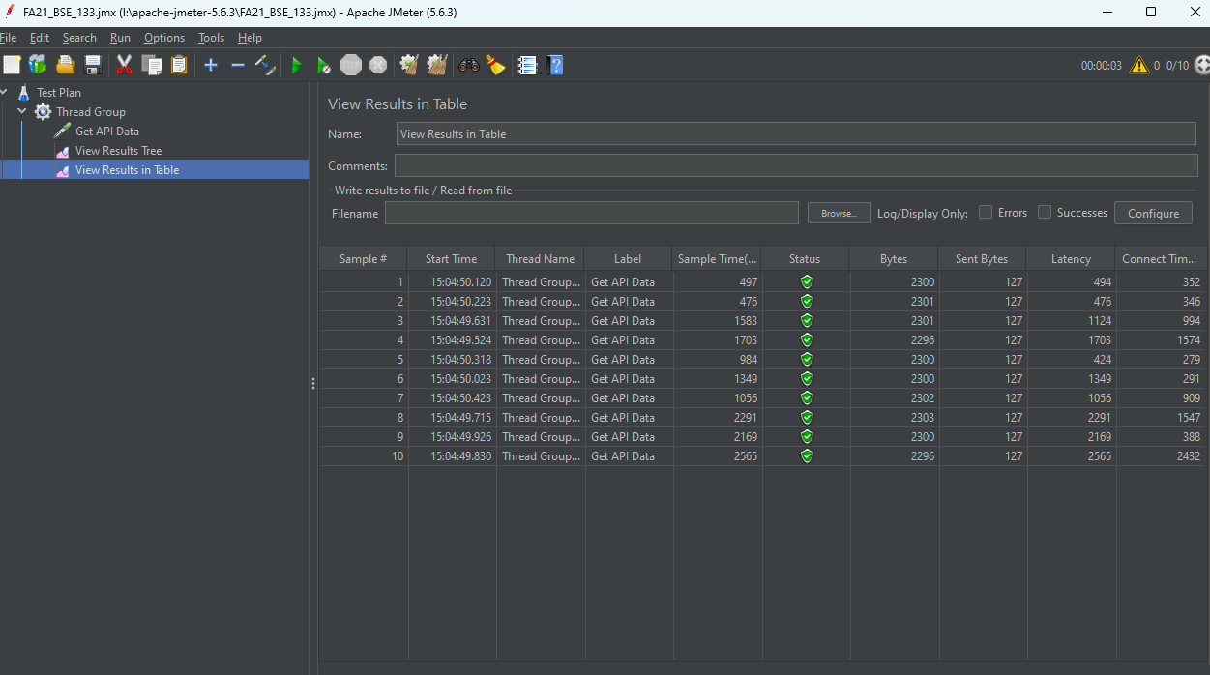We can also view the result returned by the API:
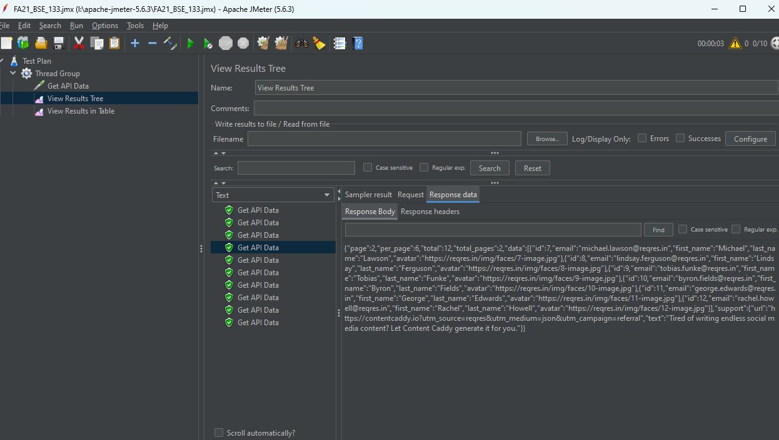

Load Testing on CUI Lahore website:
I am going to perform load testing on the following routes and store the result in a .csv file
https://lahore.comsats.edu.pk/default.aspx
https://lahore.comsats.edu.pk/admissions.aspx
https://lahore.comsats.edu.pk/career/index.aspx
https://lahore.comsats.edu.pk/student/time-table.aspx
https://lahore.comsats.edu.pk/campuslife/health-care.aspx
We can create variables and store each link inside them:
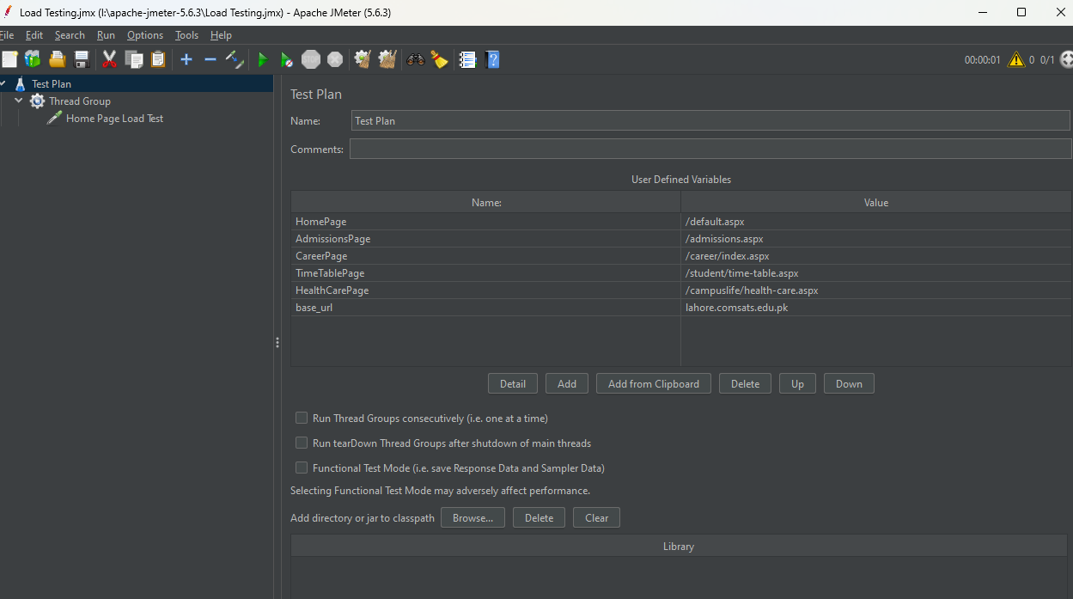

Adding all the links in HTTPS sampler:
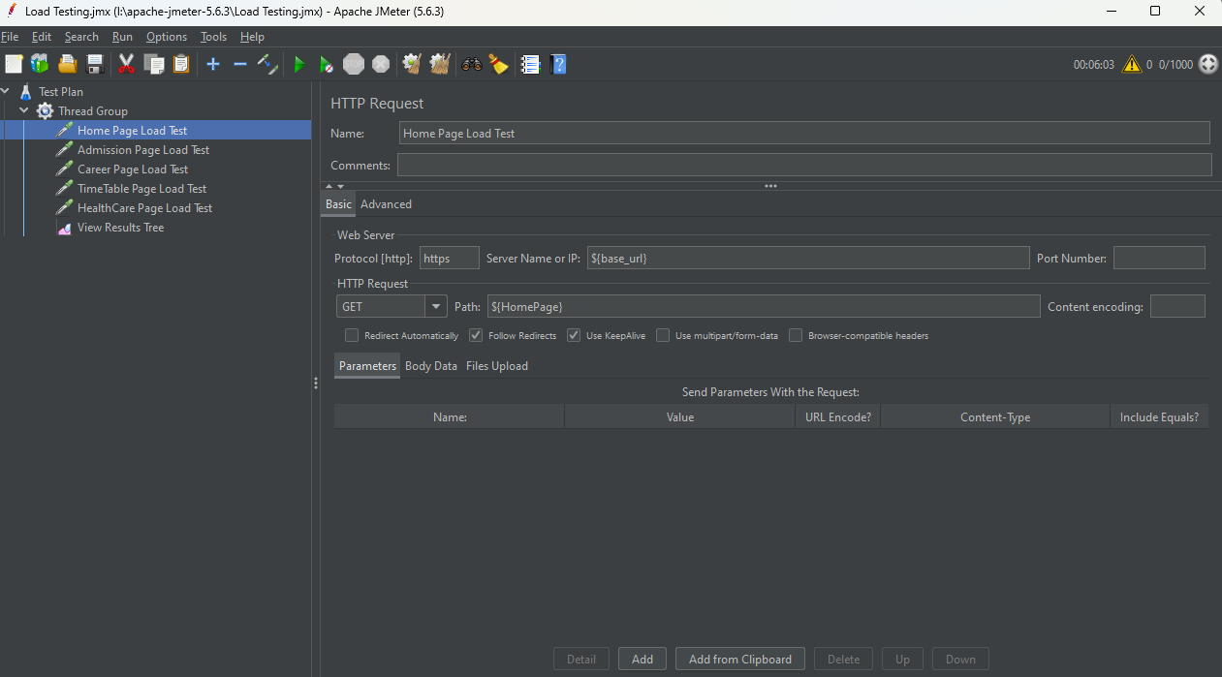
Storing result in .csv file:
jmeter -n -t "I:\apache-jmeter-5.6.3\Load Testing.jmx" -l "I:\apache-jmeter-5.6.3\Load_Testing_Result.csv"
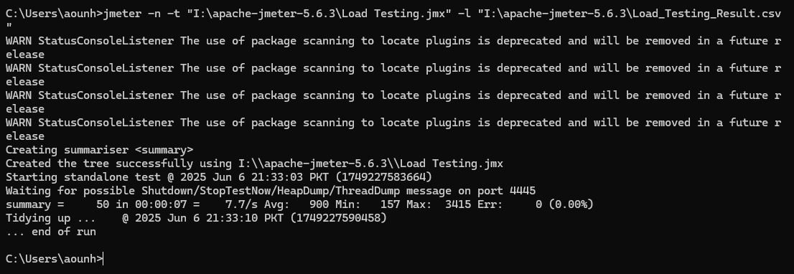
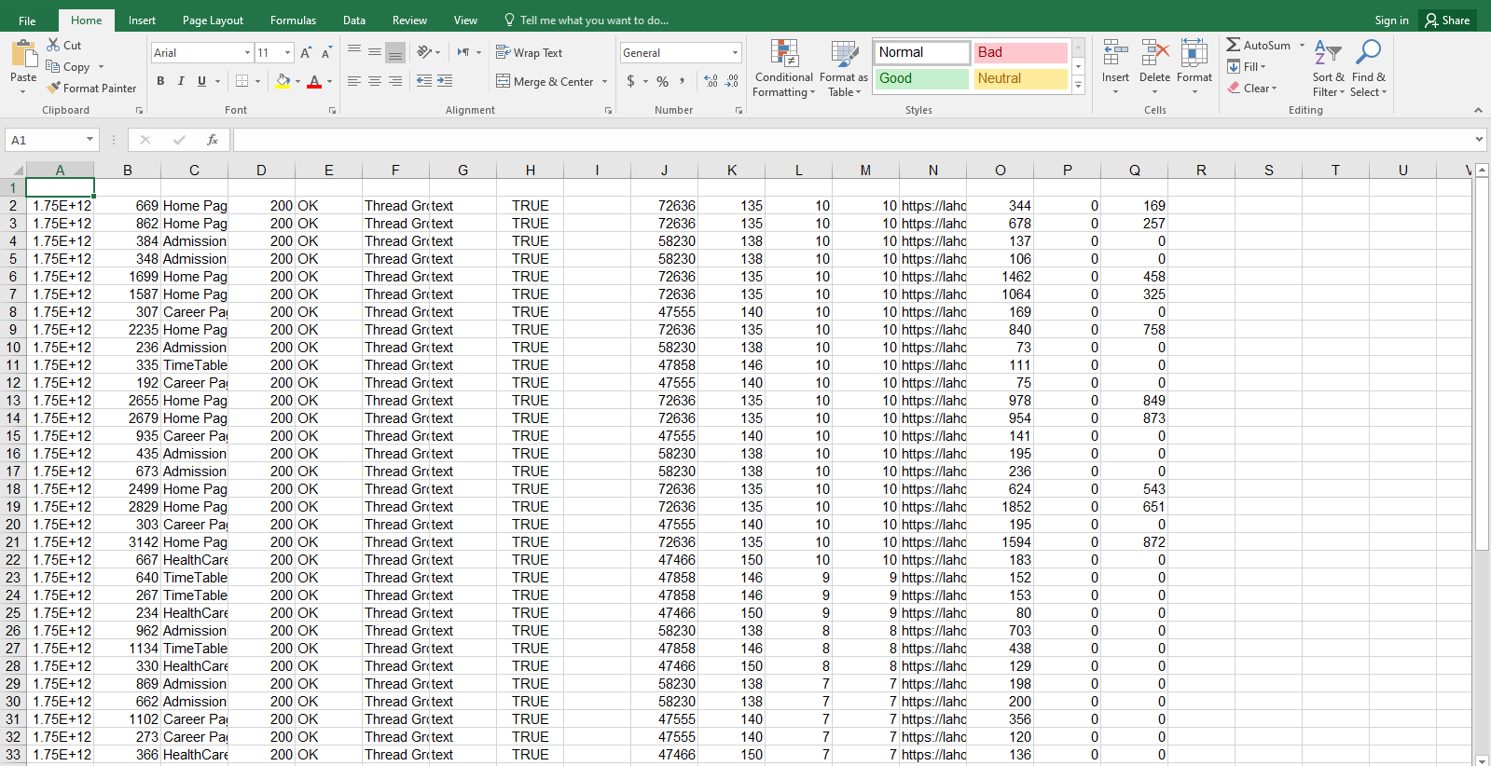
Stress Testing on same site:
Now to perform stress testing on CUI, we can set loop count in thread group to infinite and check where site becomes unresponsive.
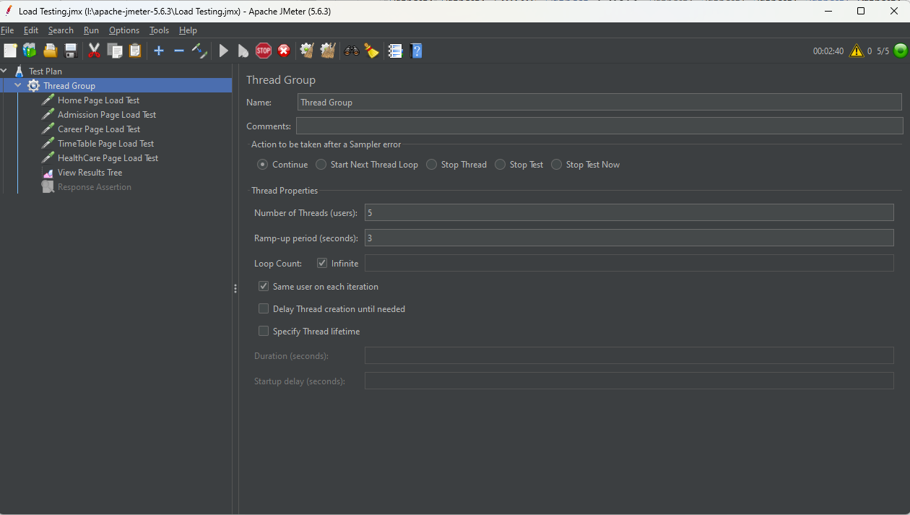
SonarQube
SonarQube provides two major test coverage and quality profile. It can detect code smells, bad coding practices, vulnerabilities in code.
Starting the sonarqube service:
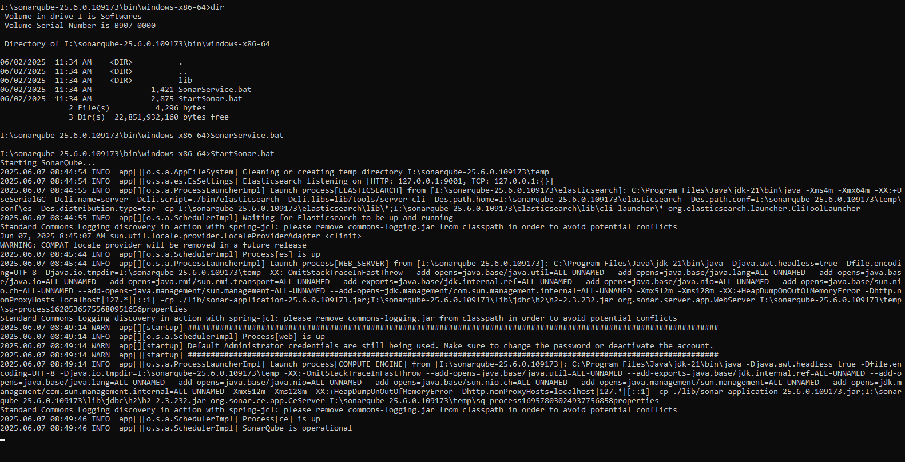

Opening localhost:9000/ in browser to access GUI:
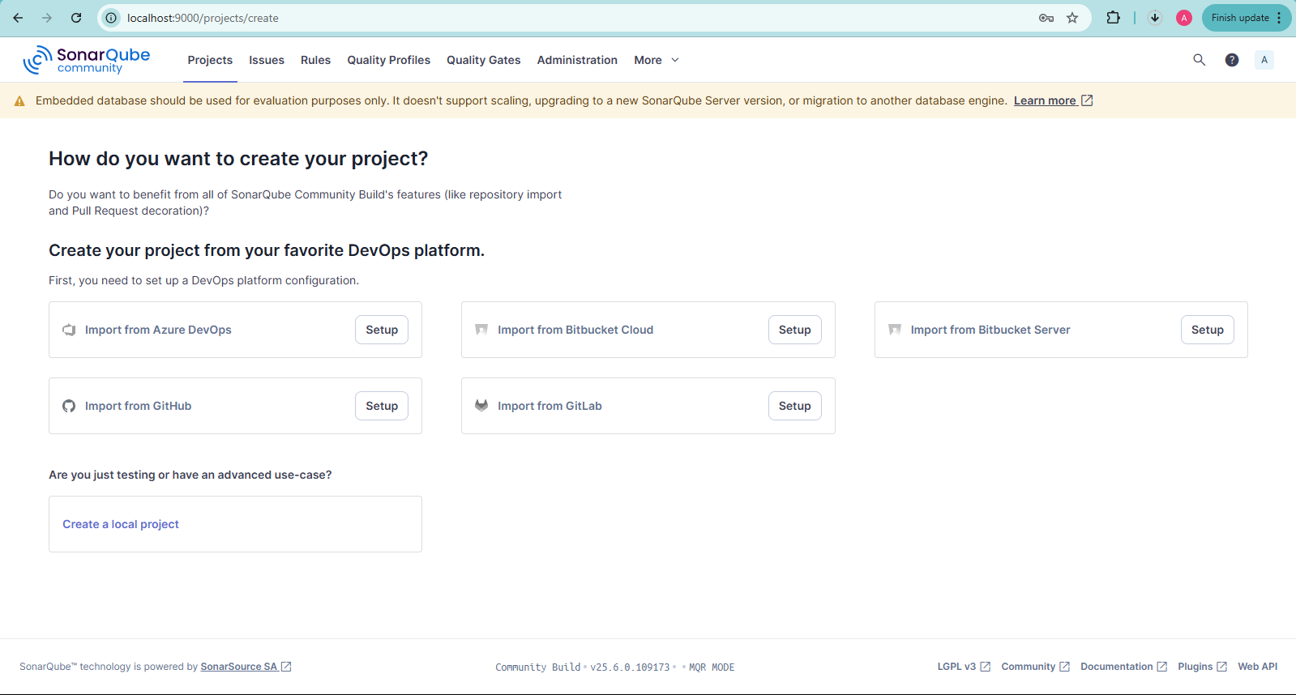
Performing GitHub integration:
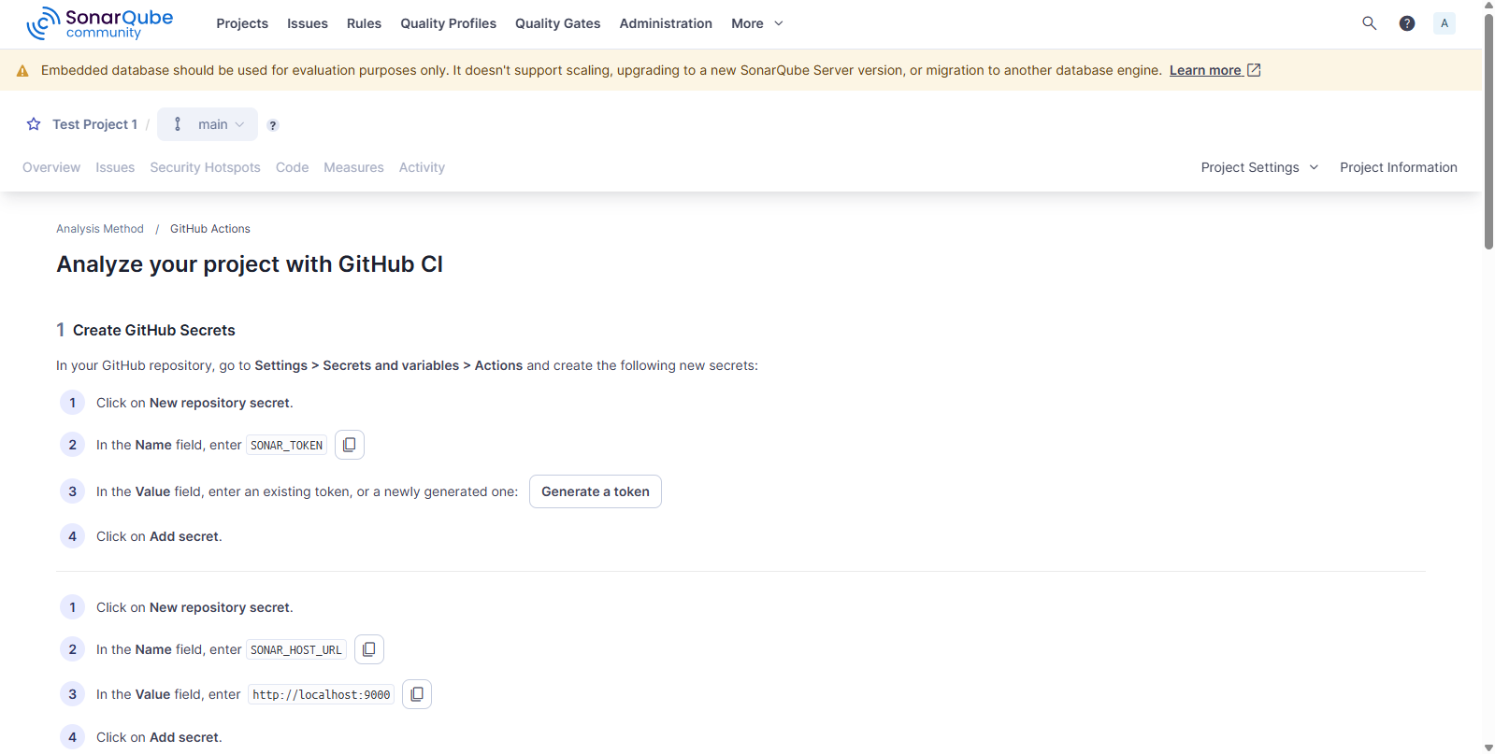

Creating a sample Java project and finding vulnerabilities:
Create a folder having .java, .class and .properties file and pass it to sonar-scanner which will generate a report which we can view in the browser, also we have to create an empty project with same key specified in sonar-project.properties file
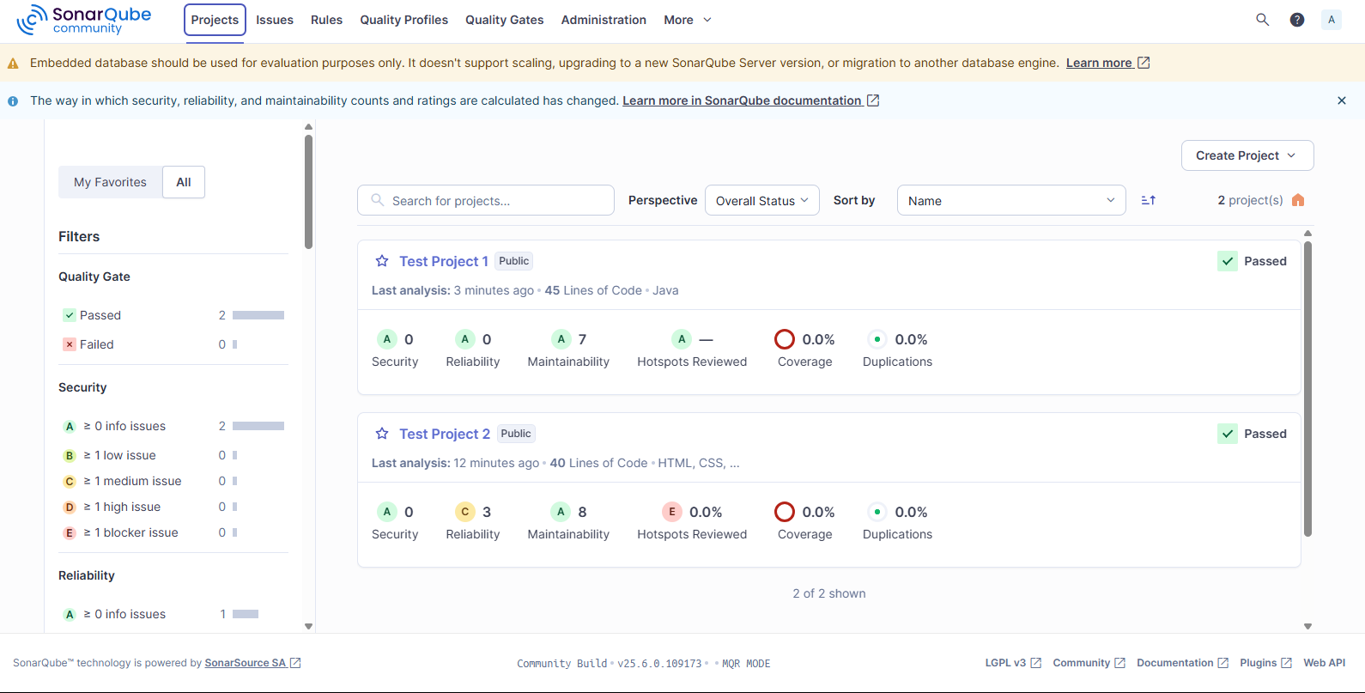
Now lets execute the sonar-scanner on the java project to see the results:
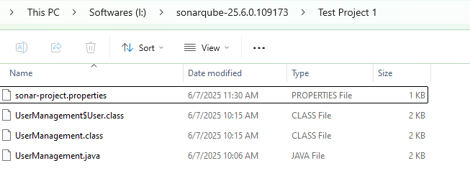
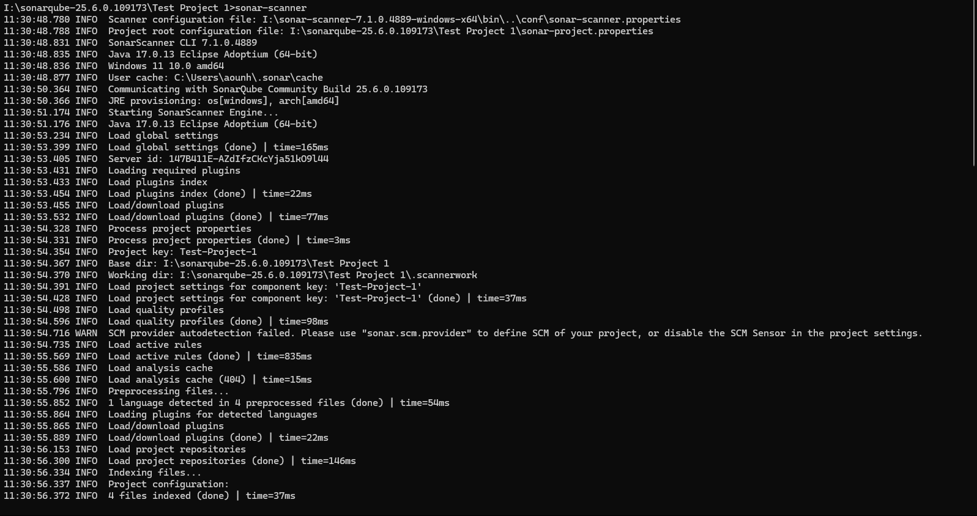
Checking the project report with all identified vulnerabilities:
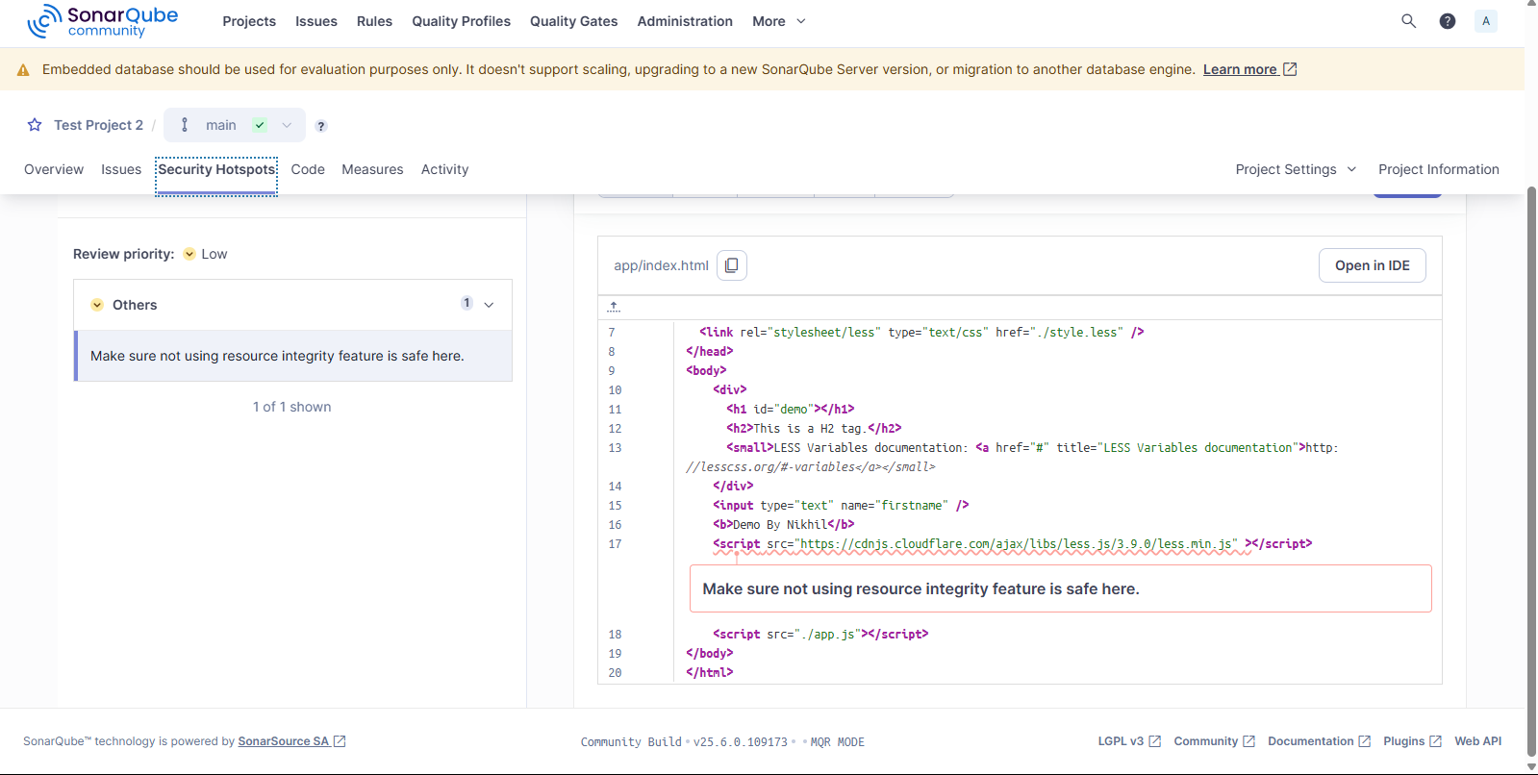

List of identified issues in the project:
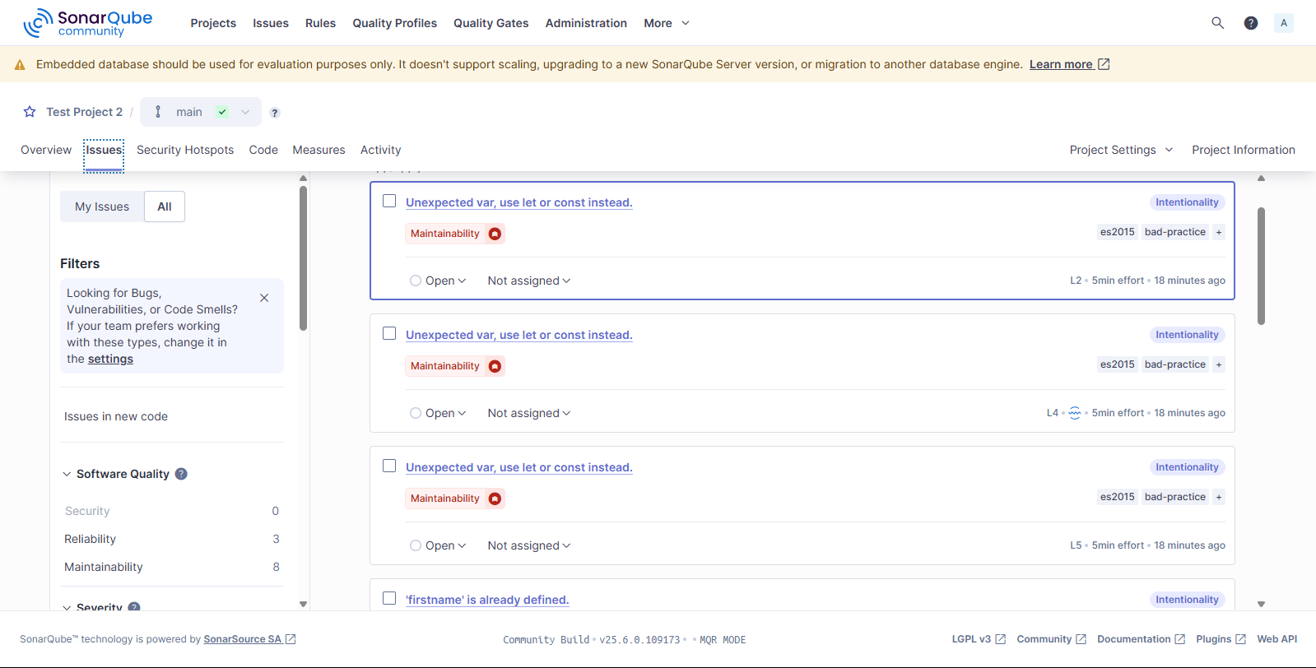
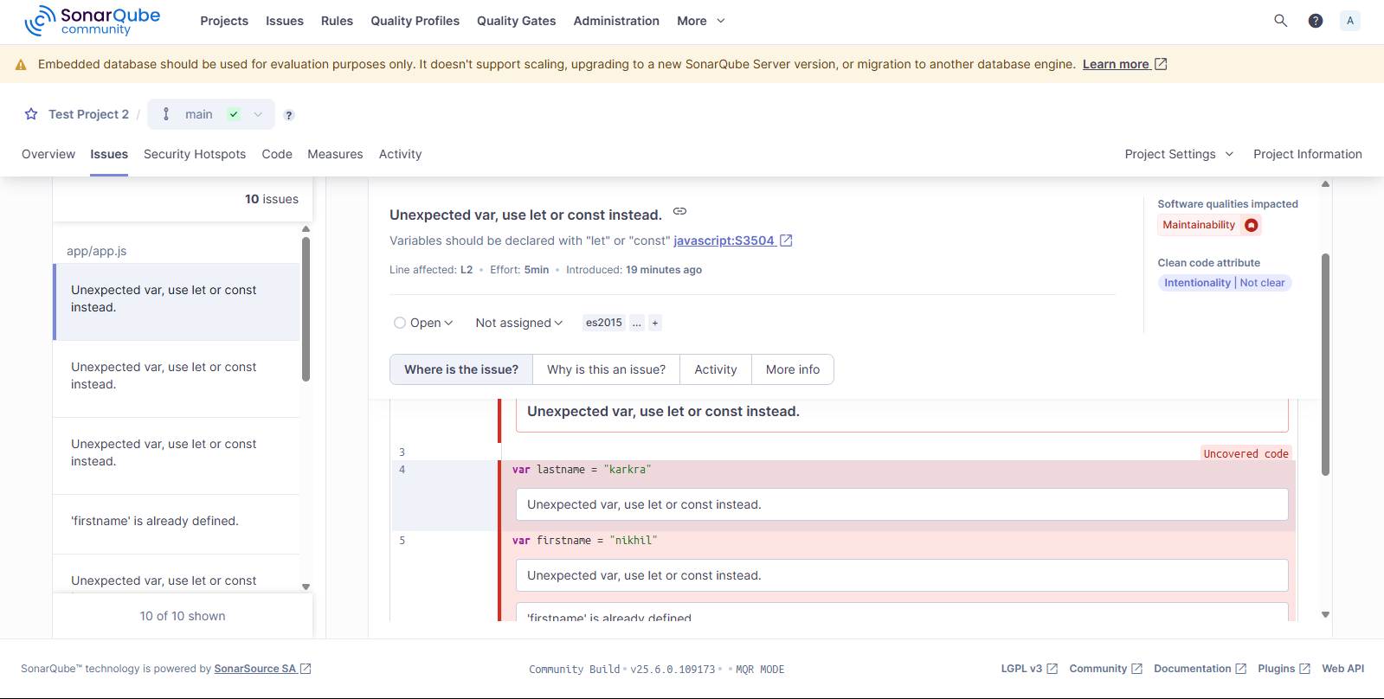
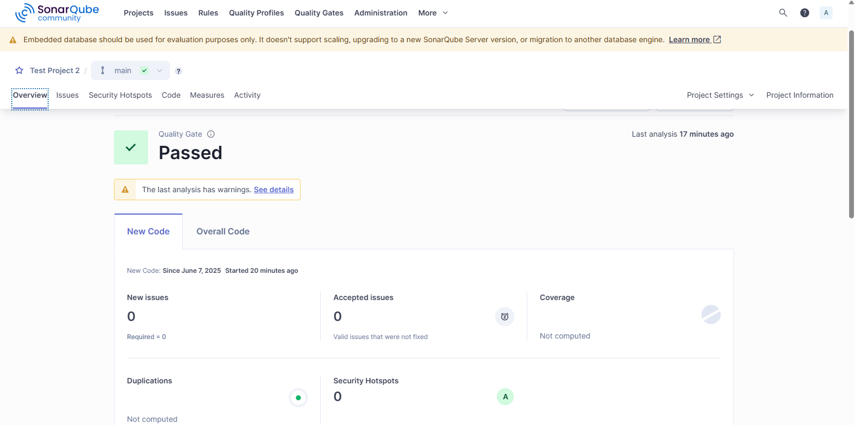
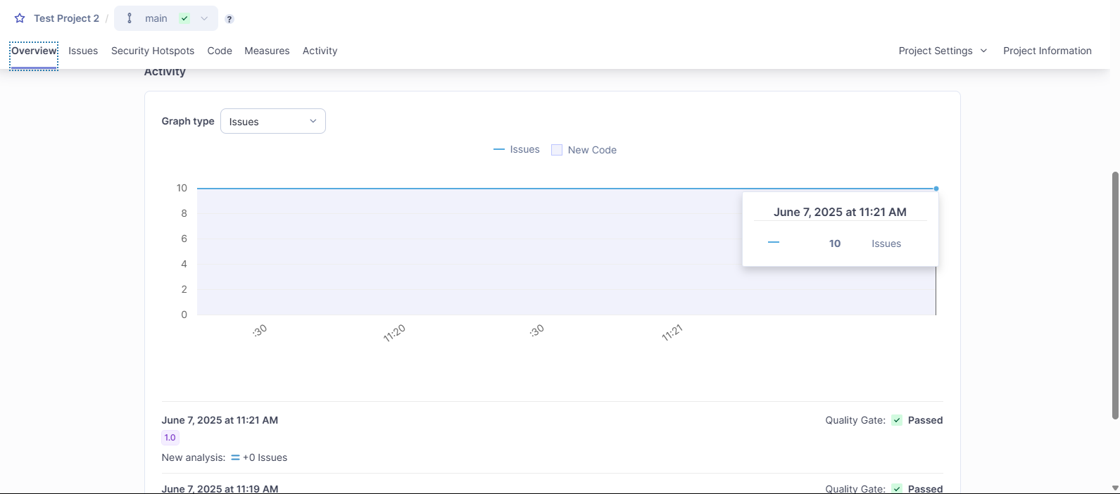

Different quality profiles for different languages which can be extended:
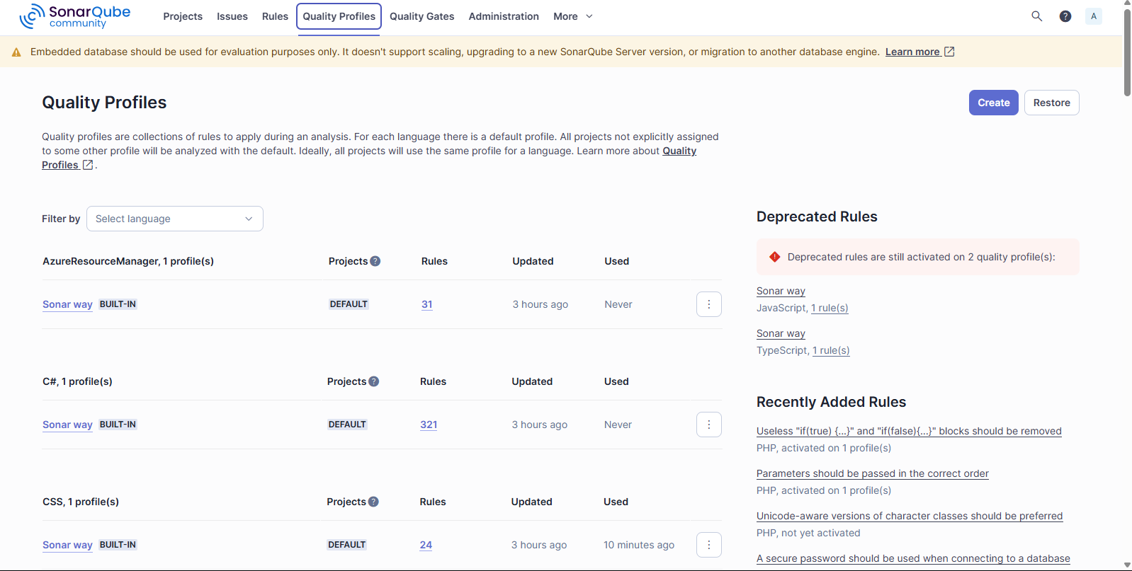
Different quality gates provided:
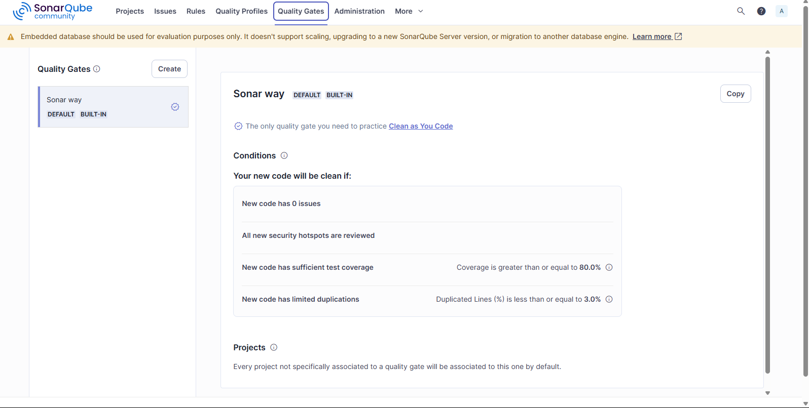

Mabl:
Mabl is an intelligent test automation tool for web applications. It uses low-code/no-code interface to create, execute and manage automated tests. It's widely used for functional testing, regression testing and continuous delivery pipelines.
I am going to test different features of automationexercise.com/ site by creating different test cases and then putting them in test suite.
Test Plan:
Test suite 1: Account authentication and account management
Test case id | Test case title | Test case description
T_1.1 | Account registration | Fill in user details and register a new user
T_1.2 | Login with valid credentials | Login with a valid account
T_1.3 | Logout functionality | Ensure logout works and session is cleared
Test suite 2: Product browsing and search
Test case id | Test case title | Test case description
T_2.1 | Browse by category | Click Electronics > Camera & Photos and list products
T_2.2 | Filter products | Filter 'Apparel' products by price
T_2.3 | Search for product | Search for 'laptop' and validate results
Test suite 3: Shopping cart functionality
Test case id | Test case title | Test case description
T_3.1 | Add product to cart | Add a specific product to cart
T_3.2 | Update quantity in cart | Change product quantity to 2 and verify total
T_3.3 | Remove product from cart | Remove an item and validate cart is empty
Test suite 4: Checkout and payment process
Test case id | Test case title | Test case description
T_4.1 | Guest checkout | Add item and proceed to checkout as guest
T_4.2 | Billing and shipping | Fill billing/shipping info and continue
T_4.3 | Select payment method | Choose method and place order
Test suite 5: UI validation and error handling
Test case id | Test case title | Test case description
T_5.1 | Form validation on registration | Leave required fields blank and validate errors
T_5.2 | Visual consistency check | Validate home page banner and layout on multiple runs
T_5.3 | Broken links check | Click footer links and validate status

Choosing a test type:
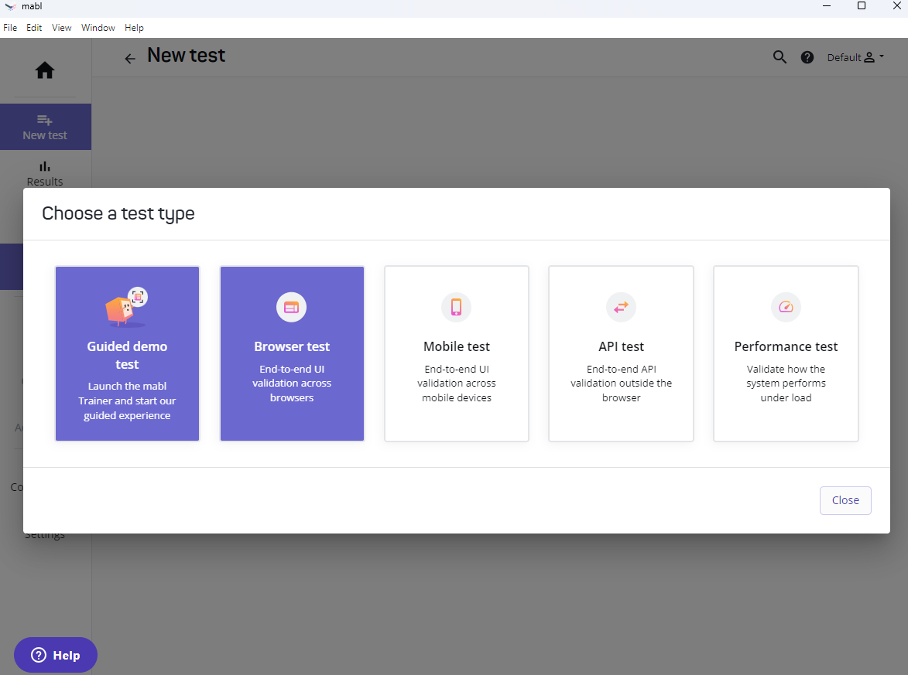
Creating test case for Add to cart feature testing:
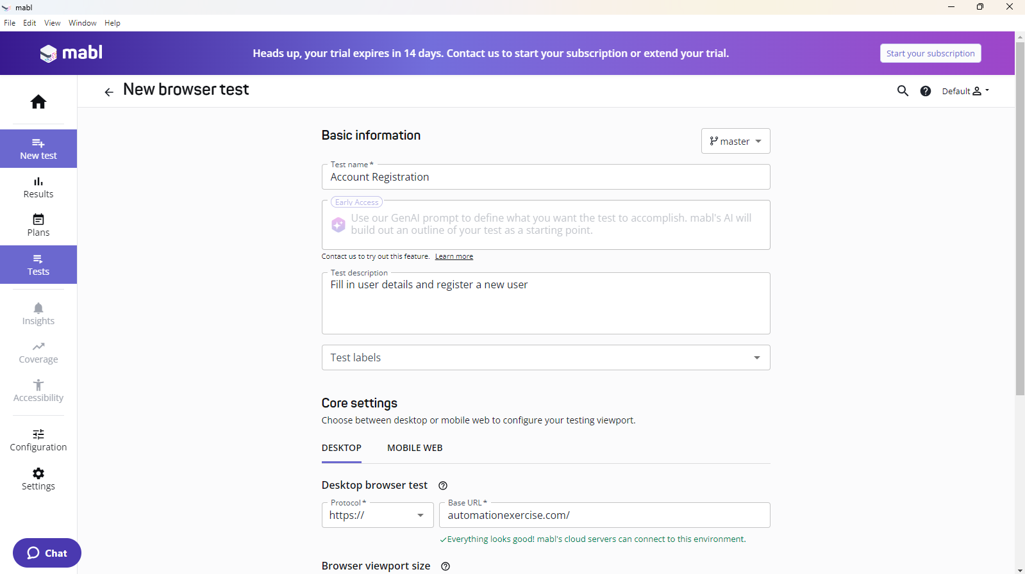
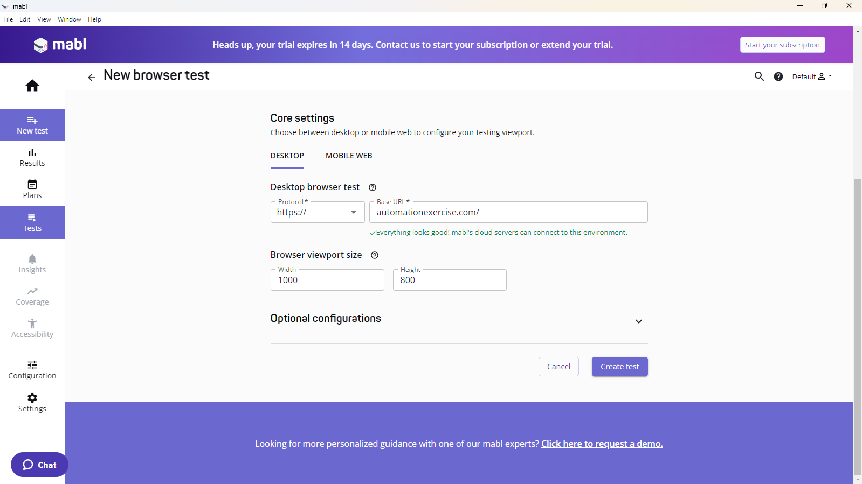

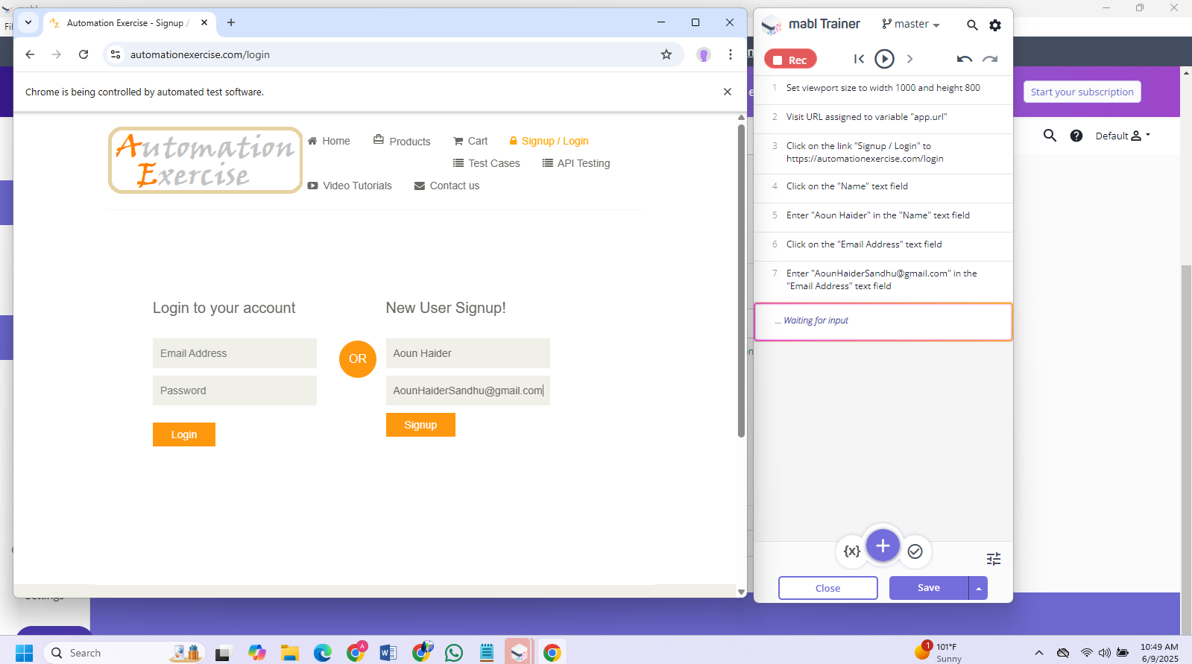
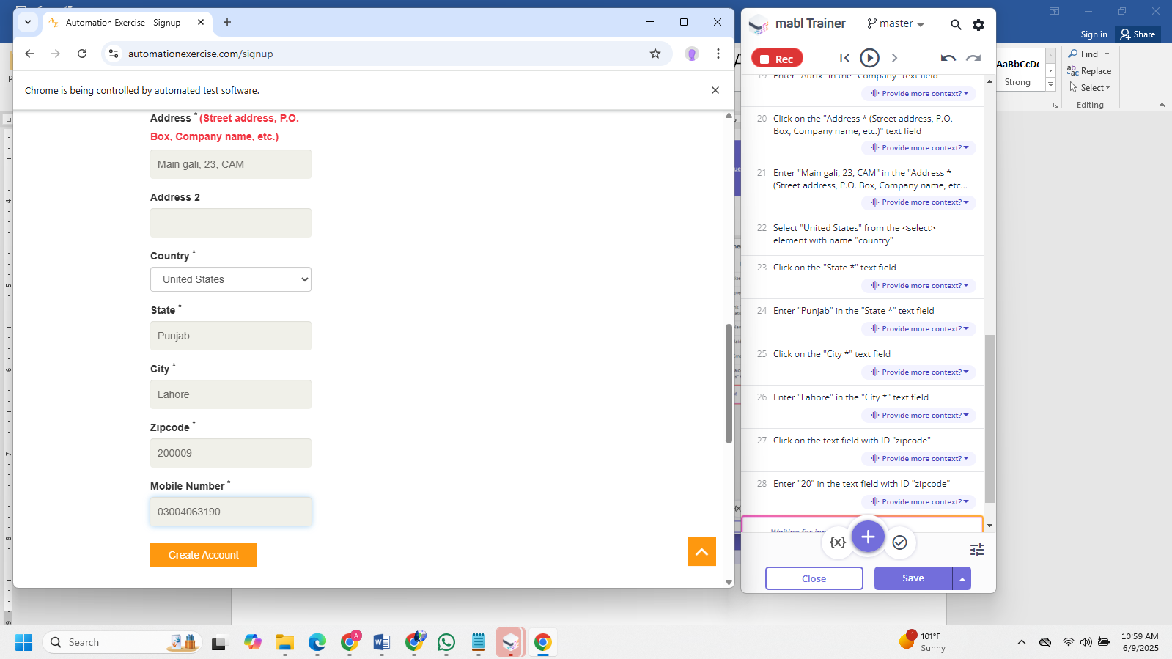
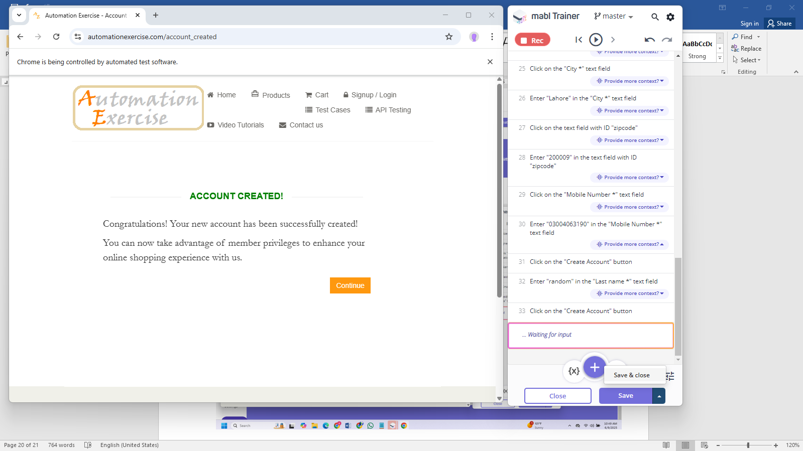

Running the test:
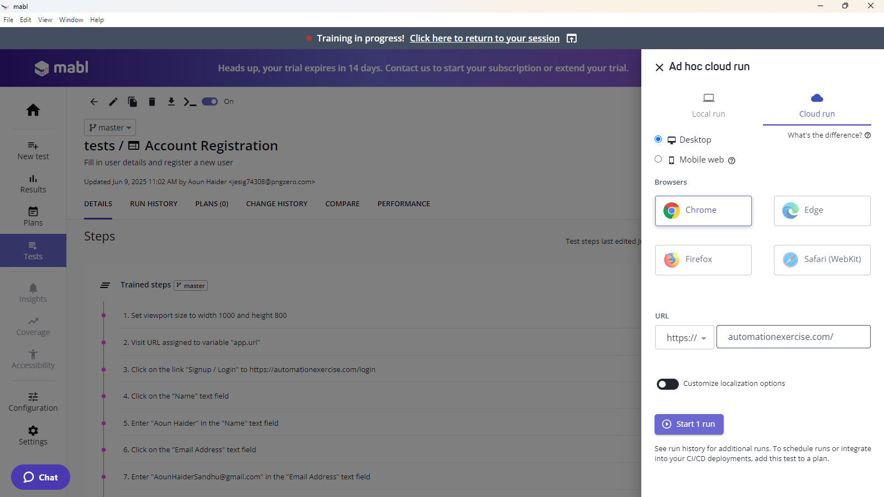
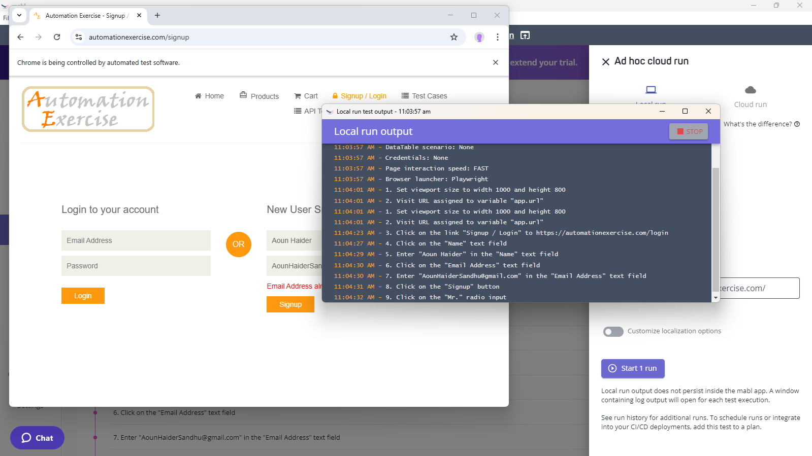
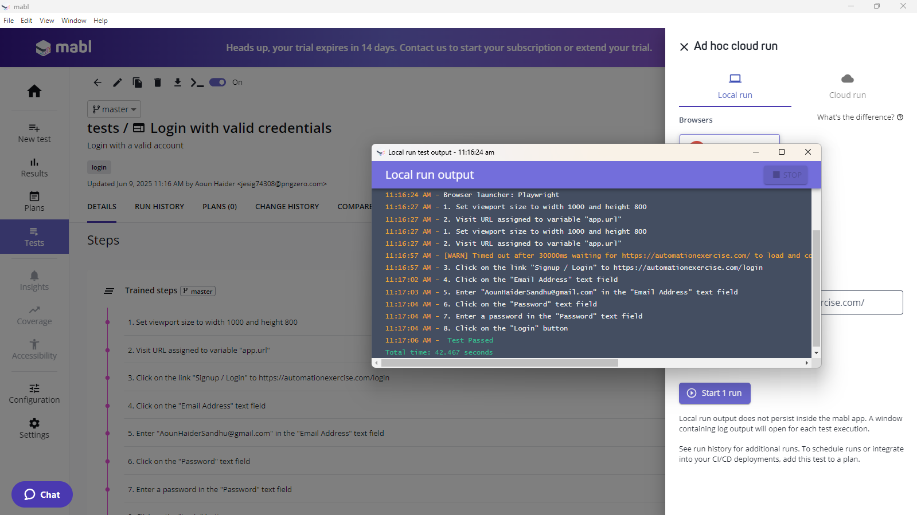
Creating a login flow, to test logout feature, login test case must be executed, so we have defined a flow here:
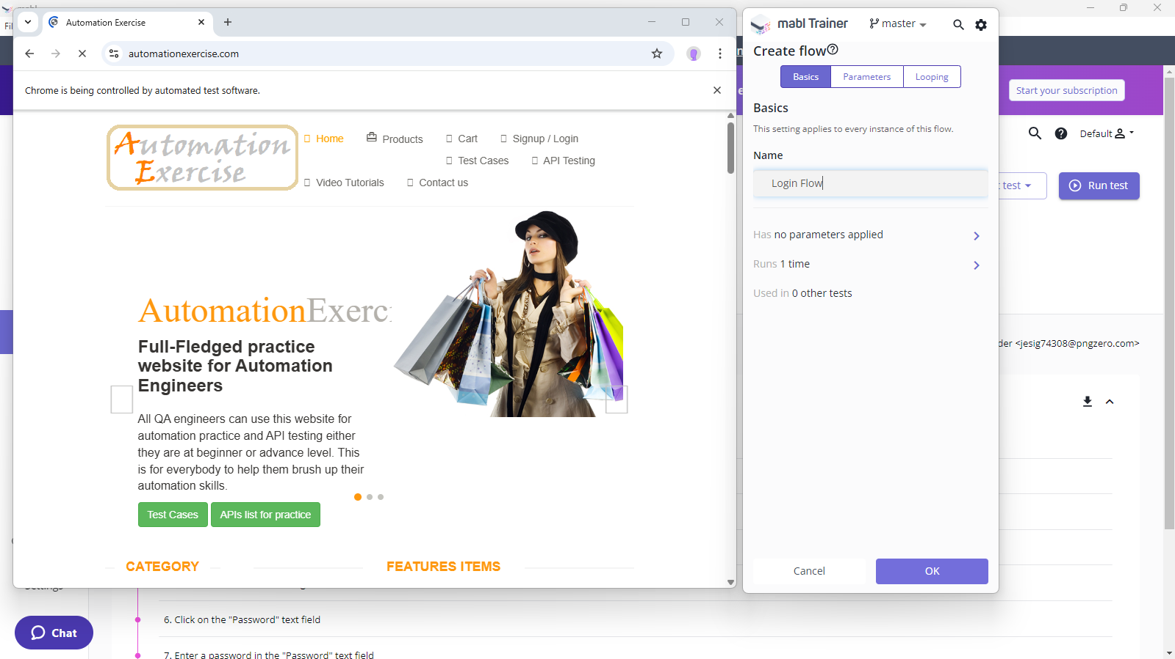
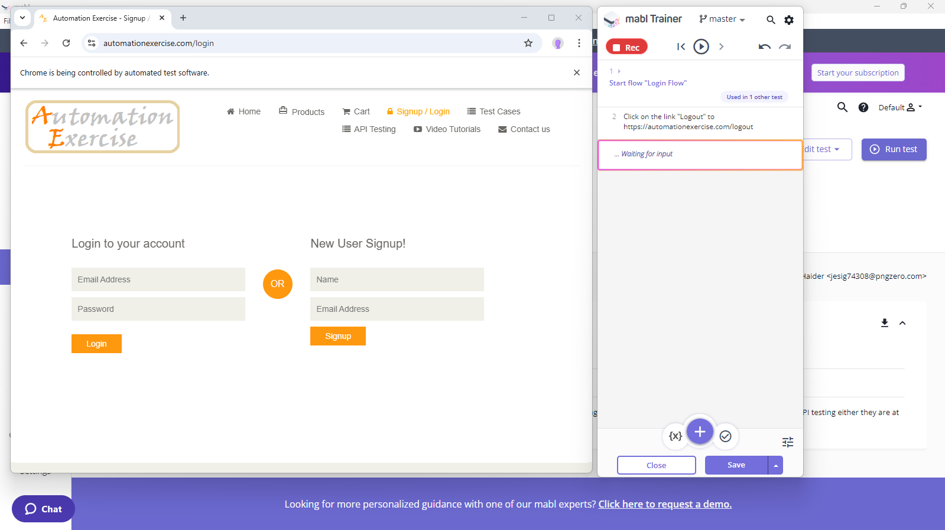
Creating a test plan:
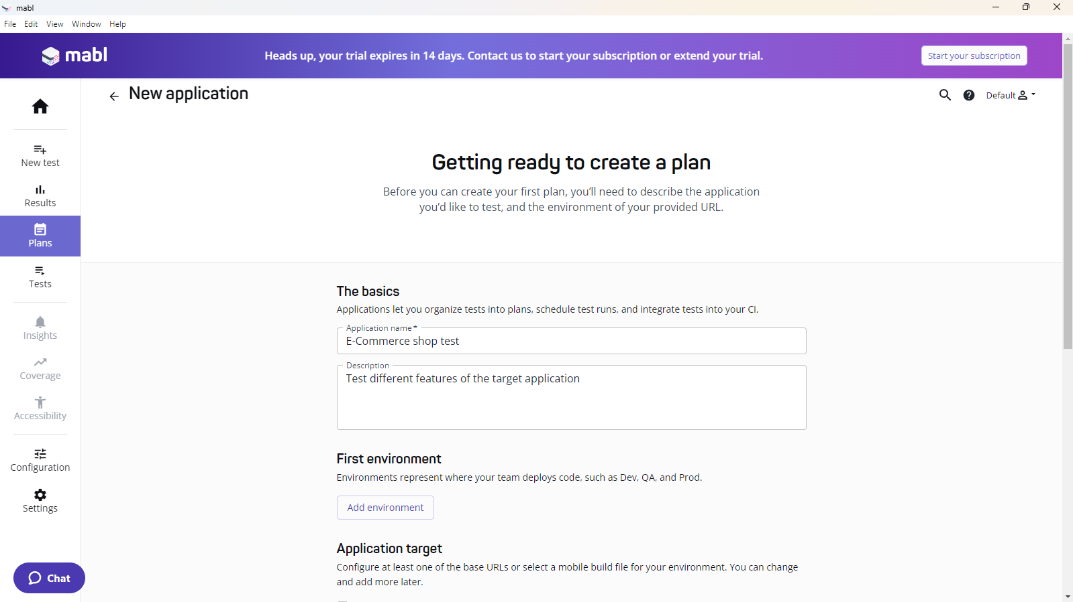
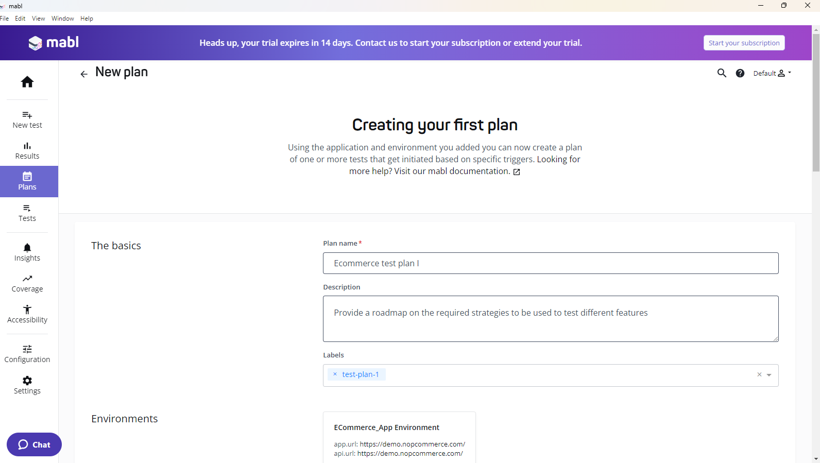
Adding test cases to stage 1 or suite 1:
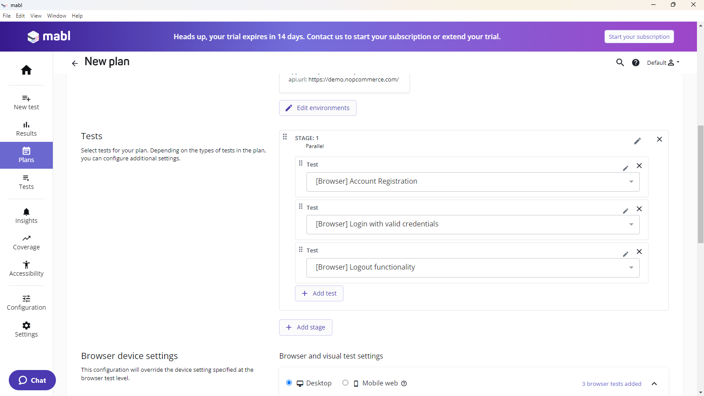

Choosing test environment:
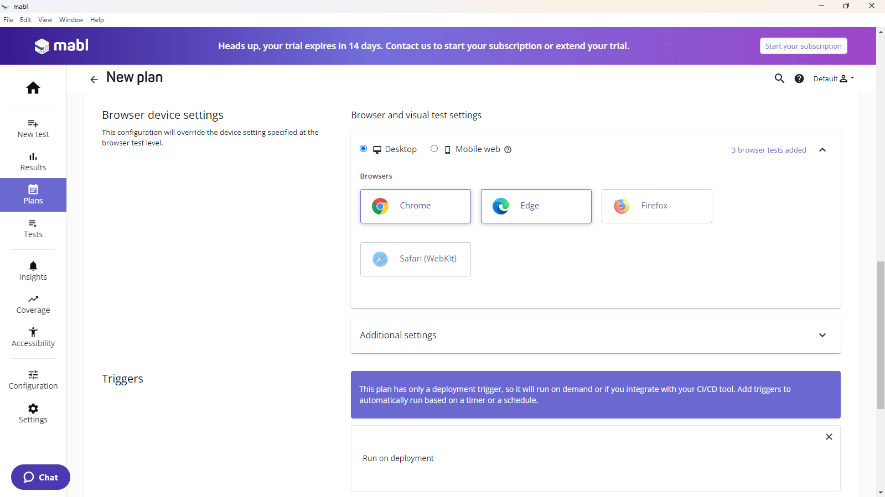
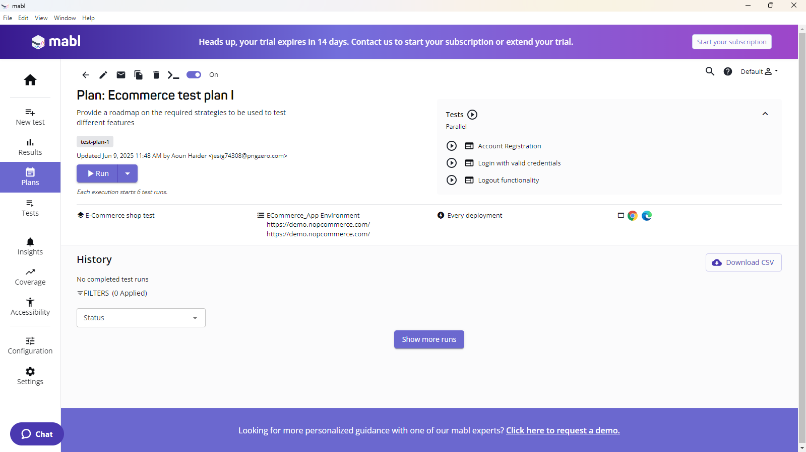

Running entire test plan:
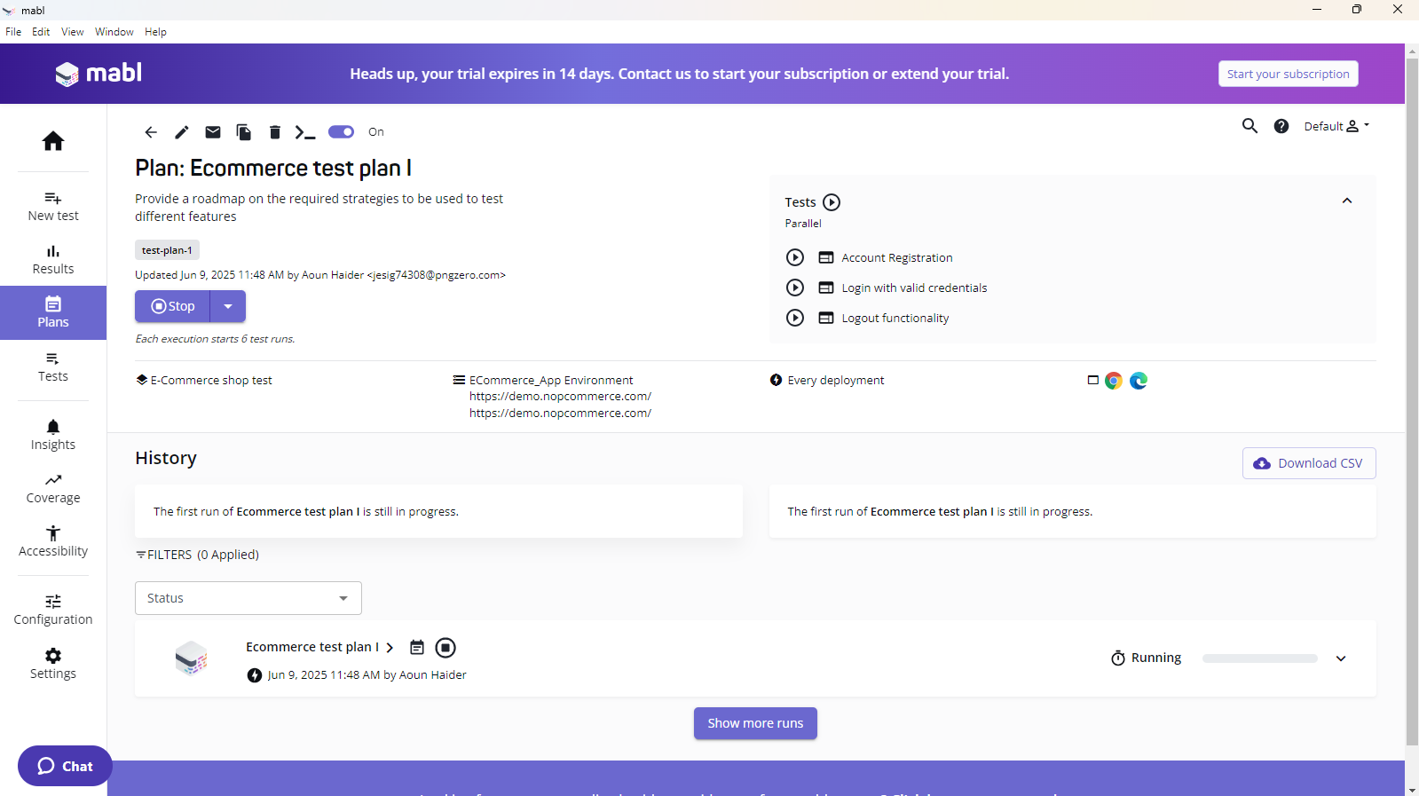
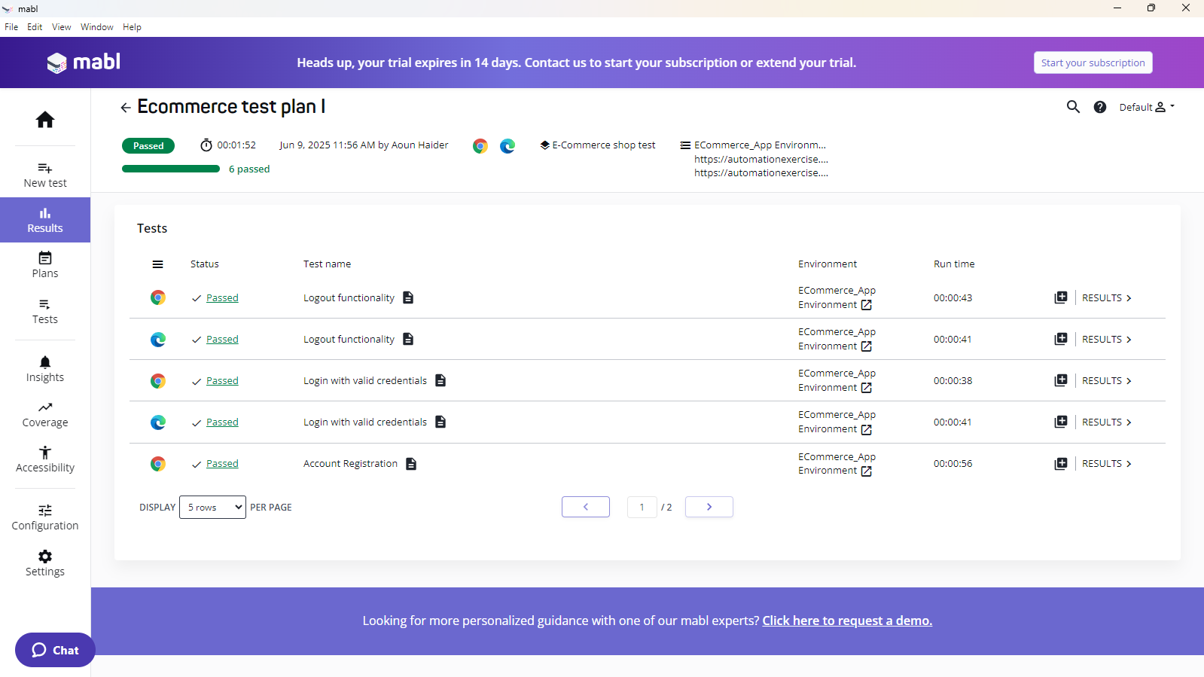

Checking test coverage:
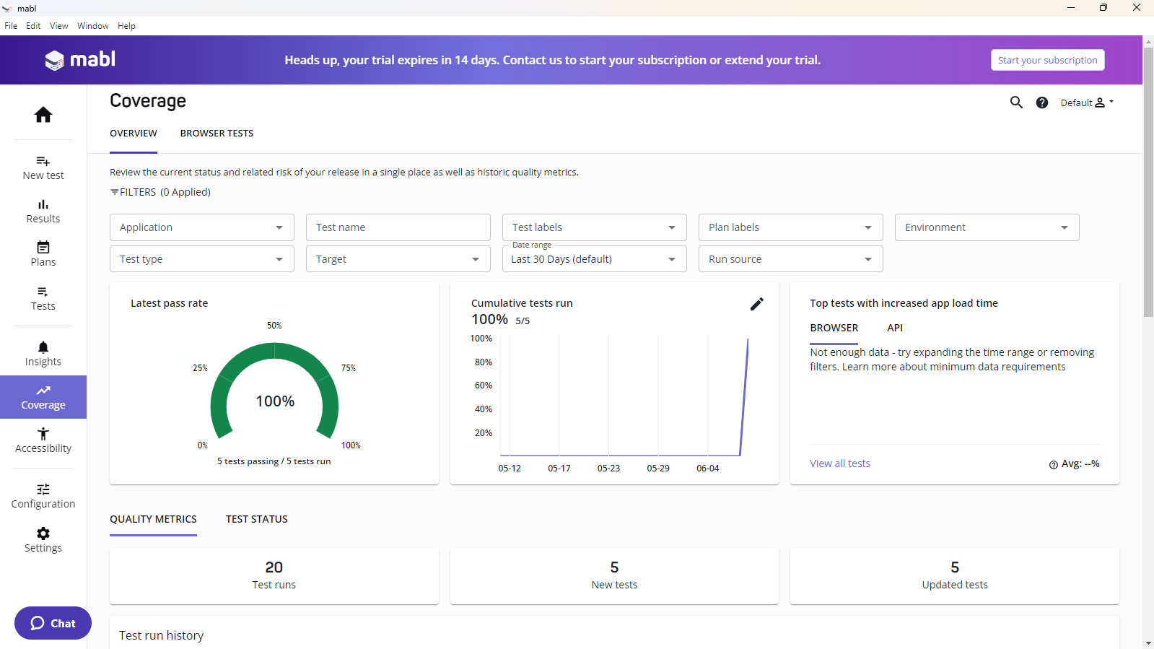
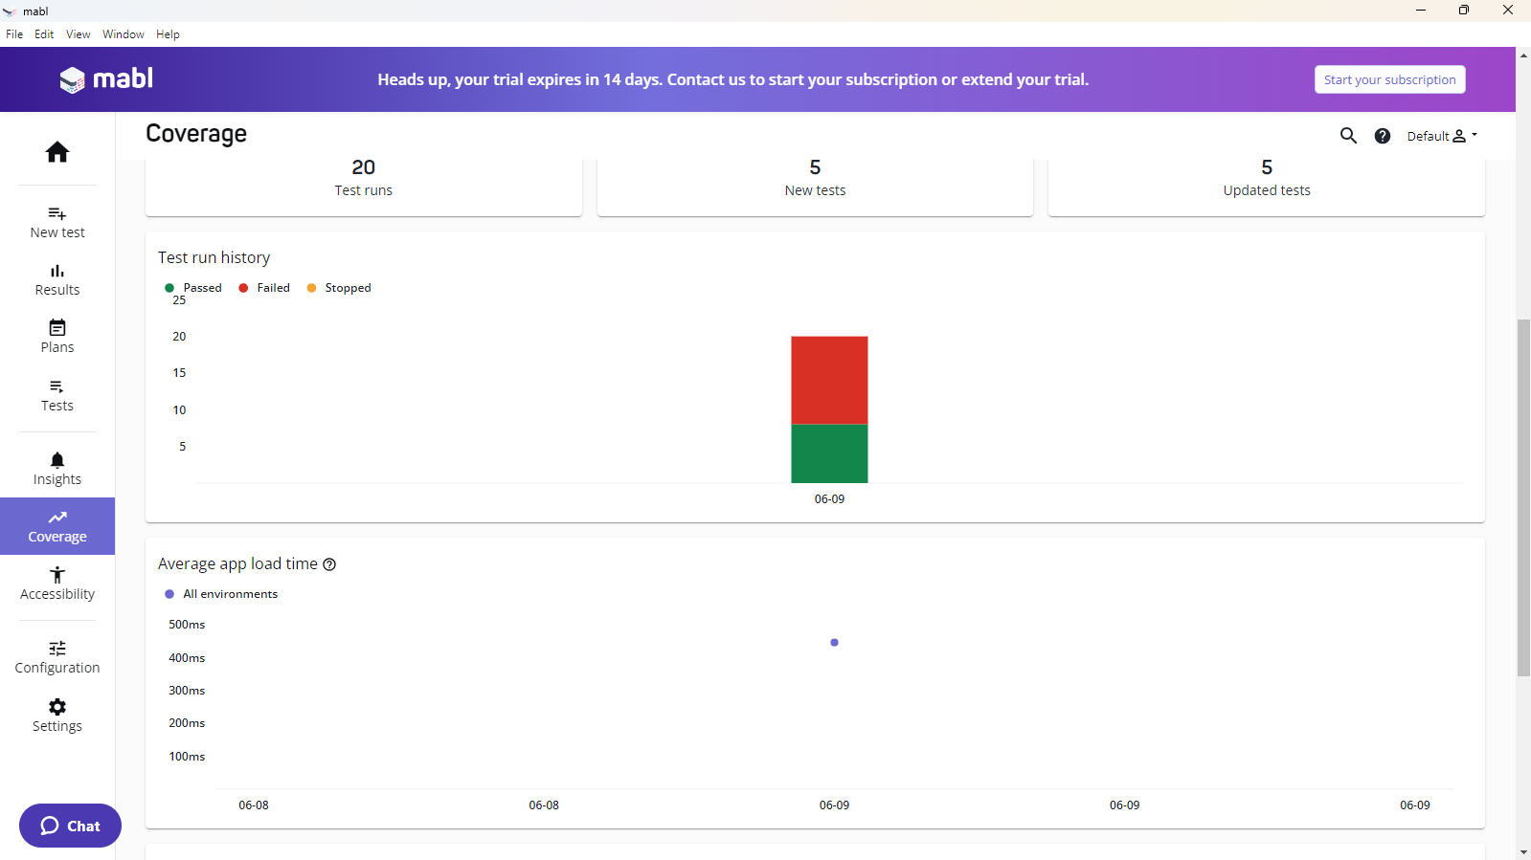

Checking accessibility test results:
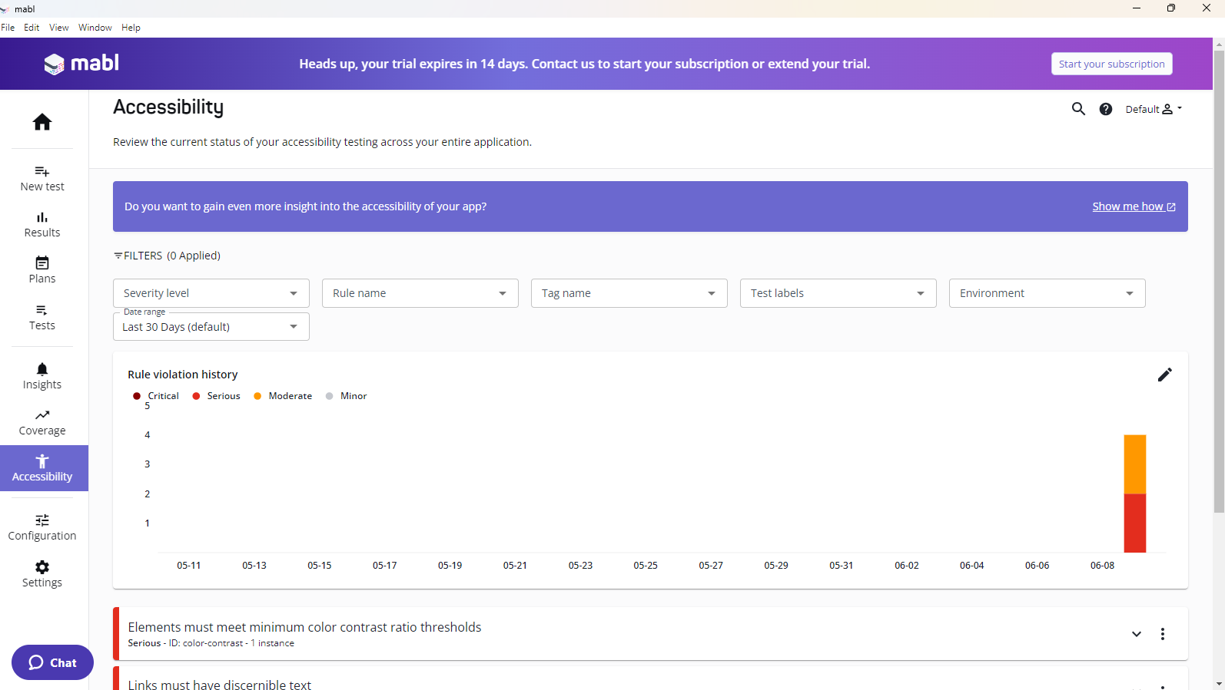
Checking insights:
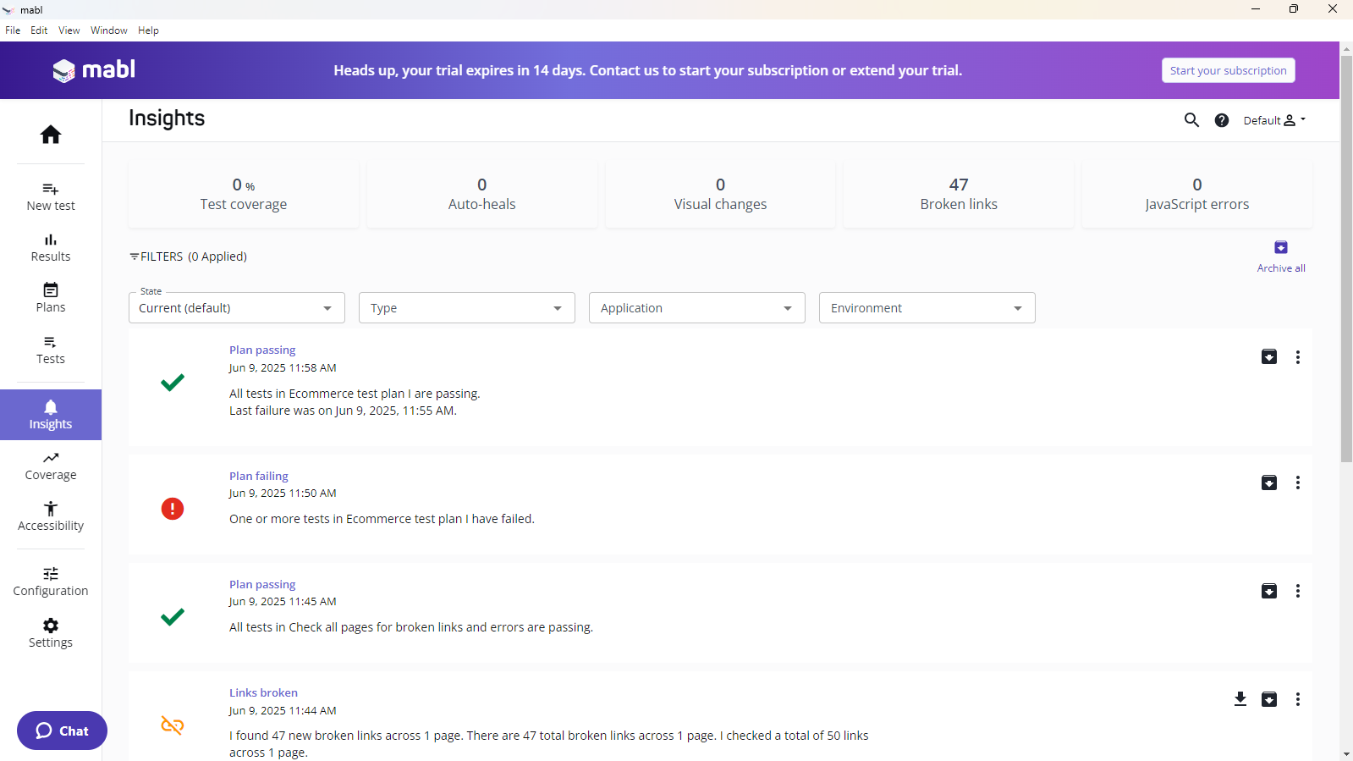
Testing tool | Video link
Apache Jmeter | https://drive.google.com/file/d/172jFSs93mSJyj57Keh4nwxsN076P5bdV/view?usp=sharing
Mabl | https://drive.google.com/file/d/1RirA93nZHfYj-Li3i9dU16JwYRWWwuWK/view?usp=sharing
SonarQube | https://drive.google.com/file/d/1NoB-Je-SNwNSePt1GLXAfQI_4Si8pQHJ/view?usp=sharing

